**BIG DATA ANALYTICS USING HADOOP ECOSYSTEM**

**by**

**MD. NAKIBUL HASSAN**

**ID: 132-15-2711**

**MD. AMINUL ISLAM**

**ID: 132-15-2704**

**AND**

**FARID OR RASHID**

**ID: 122-15-1981**

This Report Presented in Partial Fulfillment of the Requirements for the Degree of Bachelor of Science in Computer Science and Engineering

Supervised By

**Md. Sadekur Rahman**

Senior Lecturer

Department of CSE

Daffodil International University



**DAFFODIL INTERNATIONAL UNIVERSITY**

**Dhaka, Bangladesh**

**mAY 2017**

**APPROVAL**

This project titled **“Big Data Analytics Using Hadoop Ecosystem”**, submitted by Md. Nakibul Hassan, Md. Aminul Islam, Farid Or Rashid to the Department of Computer Science and Engineering, Daffodil International University, has been accepted as satisfactory for the partial fulfilment of the requirements of the degree of B.Sc. in Computer Science and Engineering and approved as to its style and contents. The presentation has been held on 15th of May.

**Board of Examiners**

**Dr. Sayed Akhter Hossain Chairman**

**Professor and Head**

Department of Computer Science & Engineering

Faculty of Science & Information Technology

Daffodil International University

**Dr. Sheak Rashed Haider Noori Internal Examiner**

**Associate Professor and Associate Head**

Department of Computer Science & Engineering

Faculty of Science & Information Technology

Daffodil International University

**Md. Zahid Hasan Internal Examiner**

**Associate Professor**

Department of Computer Science & Engineering

Faculty of Science & Information Technology

Daffodil International University

**Dr. Mohammad Shorif Uddin External Examiner**

**Professor and Chairman**

Department of Computer Science & Engineering

Jahangirnagar University

**DECLARATION**

We hereby declare that this project has been done by us under the supervision of **Md. Sadekur Rahman, Senior Lecturer**, Department of Computer Science & Engineering, Daffodil International University. We also declare that neither this project nor any part of this project has been submitted elsewhere for award of any degree or diploma.

**Supervised by:**

__________________

**Md. Sadekur Rahman**

**Senior Lecturer**

Department of Computer Science & Engineering

Faculty of Science & Information Technology

Daffodil International University

**Submitted by:**

__________________

**MD. Nakibul Hassan**

**ID: 132-15-2711**

Department of Computer Science & Engineering

Faculty of Science & Information Technology

Daffodil International University

__________________

**MD. Aminul Islam**

**ID: 132-15-2704**

Department of Computer Science & Engineering

Faculty of Science & Information Technology

Daffodil International University

__________________

**Farid Or Rashid**

**ID: 122-15-1981**

Department of Computer Science & Engineering

Faculty of Science & Information Technology

Daffodil International University

**ACKNOWLEDGEMENT**

In the name of almighty **Allah**, the most Gracious and the most Merciful, All praises to Almighty Allah for giving us the strength, ability to being patient during our project and His blessing in completing our project.

There are few peoples whom we would like to thanks for completing and helping us to complete this project.

Special thanks to our honorable supervisor **Md. Sadekur Rahman**, **SeniorLecturer**, Department of Computer Science and Engineering, Daffodil International University for his continuous support and help. Whenever we were in trouble, we went to his desk and his desk was always open for to get helped. His endless patients, scholarly guidance, gentle behavior, continuous encouragement have made it possible to complete this project. We would like to thanks all the faculty members of CSE who helped us during this project.

We would like to express our heartiest gratitude to **Dr. Syed Akhter Hossain, Professor and Head,** Department of Computer Science and Engineering, for his kind help to finish our project and also to other faculty member and the staff of Computer Science and Engineering department of Daffodil International University.

We would also like to thanks all the friends of Daffodil International University for their support and help. We are also thankful to our senior brother of Daffodil International University for giving us advice to complete our project.

Last but not least, our deepest thanks to our parents to help us and for their kindness and giving us moral and financial support during project.

**ABSTRACT**

In 21st century, due to technological advancement, the amount of data getting generated is huge. The data volumes are exploding, around 90% of total data has been created past four to five years. Data is growing so faster that by the year 2020, about 1.7 megabytes information will be created each second for each human being on the planet. Enterprises worldwide will need to preform analytics on this huge data sets to make decision and stay competitive.

Previously traditional RDBMS (Relational Database Management System) was used to store data and analytics over data. But in today’s world, RDBMS will not be efficient and time consuming to perform analytics over this huge data. Hadoop came into existence recently to recue us and overcomes RDBMS limitations by providing simplified tools for huge data storage, faster processing on these huge data or we can say Big Data. Hadoop framework has to core components, one is HDFS (Hadoop Distributed File System) and another is Hadoop MapReduce a programming model. There are numbers of Big Data tools build on top of Hadoop which together form ‘Hadoop Ecosystem’. One of the big Data tool is Apache Pig. Pig is a platform where large data set is analyzed using a data flow language, PigLatin.

The purpose of our project is to study different Hadoop ecosystems in details and perform data analytics on a movie data set using Hadoop. A movie data set consisting around fifty thousand records for analytics .Different use cases have been considered and analytics have been performed using MapReduce and Pig functionalities of Hadoop.

**TABLE OF CONTENTS**

**CONTENT Page No**

Board of Examinersi

Declaration ii

Acknowledgement iii

Abstract iv

Table of Contents v

List of Figures vii

List of Tables viii

**CHAPTER**

**CHAPTER 1: INTRODUCTION** 1-3

* 1. Introduction 1
  2. Motivation 2
  3. Aim of The Project 3
  4. Expected Outcome 3
  5. Report Layout 3

**CHAPTER 2: BACKGROUND** 4-7

2.1 Definition of Big Data 4

2.2 Evolution of Big Data 4

2.3 Characteristics of Big Data 5

2.4 Scope of the Problem 6

2.5 Challenges 7

**CHAPTER 3: REQUIREMENT SPECIFICATION** 8-10

3.1 Hadoop 8

3.2 Hadoop Architecture 8

3.3 HDFS (Hadoop Distributed File system) 9

3.4 MapReduce 10

3.5 Pig 10

**CHAPTER 4: DESIGN SPECIFICATION** 13-18

4.1 Introduction 13

4.2 Virtual machine installation 13

4.3 Configure virtual machine 14

4.4 Loading Data into HDFS 16

**CHAPTER 5: IMPLEMENTATION AND TESTING** 19-30

5.1 Movie Data set 19

5.2 Movie Data Analytics 21

**CHAPTER 6: CONCLUSION AND FUTURE SCOPE** 31

6.1 Discussion and Conclusion 31

6.2 Scope for future Development 31

**Appendices** 32

Appendix A: Project Reflection 32

Appendix B: Related Diagram 32

**REFERENCES** 33

**LIST OF FIGURES**

**FIGURES Page No**

Figure 2.1: Characteristics of Big Data 5

Figure 3.1: Hadoop Architecture 9

Figure 3.2: Architecture of Apache Pig 12

Figure 4.1: Virtual Machine Installation 14

Figure 4.2: Home Screen of Edureka Virtual Machine 15

Figure 4.3: Checking all the Daemons of Hadoop 16

Figure 4.4: Copy data into HDFS from Local system 17

Figure 4.5: Data Sanity check in HDFS web log 18

Figure 5.1: Sample Movie data set in CSV format 20

Figure 5.2: Starting Pig grunt shell in MapReduce mode 22

Figure 5.3: Loading Data using Pig 23

Figure 5.4: Execution of the Pig Script of use case 1 23

Figure 5.5: Successful execution of Pig Script of use case 1 24

Figure 5.6: Output of the use case 1 in HDFS 25

Figure 5.7: Use case 2 Pig Script 25

Figure 5.8: Successful execution of Pig script of use case 2 26

Figure 5.9: Output of the use case 2 in HDFS 27

Figure 5.10: Pig Script of the use case 3 27

Figure 5.11: Successful execution of Pig script of use case 3 28

Figure 5.12: Output of the Pig Script of use case 3 in HDFS 28

Figure 5.13: Pig Script of the use case 4 29

Figure 5.14: Successful execution of Pig script of use case 4 29

Figure 5.15: Output of the Pig Script of use case 4 in HDFS 30

**LIST OF TABLES**

**TABLES Page No**

Table 5.1: Description of the Movie Data Set 19

**CHAPTER 1**

**INTRODUCTION**

* 1. **Introduction**

RDBMS (Relational Database Management System) was first developed by IBM in 1974. But first commercially available RDBMS was Oracle which was released in 1979. However RDBMS become popular in 1980’s. By then, Oracle used a relational model system. The model was that they maintain a relation between tables using primary keys, foreign keys and indexes. However, in that time RDBMS was efficient for small and structure data sets as that time data generation speed was not so high because of lack of technology [1].

Today, we are at the time of modern technology. Technology is getting advanced day by day and new technologies are adding our life day by day. By the advancement of technology, data generation speed is high and the size of data is getting bigger. Data sets are not only bigger, their format has variations. For example, text format, JSON format, audio, video, JPEG, XML etc. For this huge and unstructured data, traditional data analytics tools like RDBMS is inefficient and can’t handle various types of data which we called unstructured data. RDBMS can’t handle this large data. For this, modern world need a new technology to handle this large data sets.

As world needed a new technology, they start trying to find a new tools to handle this large data set. As a result they discover new tools like Hadoop to handle this large data set and this large data set now a days called Big Data. All the giant tech company like IBM, Microsoft, Facebook, Amazon are using Big data technology. Big data is a new technology and Hadoop was invented near 2006. So research is ongoing on Big Data and Hadoop. There are few tool which is built on top of Hadoop to analyze Big Data which is called Hadoop ecosystem. By using Big data analytics tools like Hadoop we can store large amount of data and analyze them by using different Hadoop ecosystem tools depending on one’s need .There are lots project are developing on Big data. By developing this project one can store their data and analyze them and extract value out the large data set as their need.

* 1. **Motivation**

Big Data market is continuously getting larger each year rapidly. Each year data is getting doubled than precious year. In March, 2012, White House announced a national “Big Data Initiative” that consisted of Six Federal Departments committing more than $200 million on Big Data projects and researches. In 2016, Big Data is one of the top emerging technology [4]

Global Pulse is a flagship innovation initiative of the UN secretary-general on Big Data. Global Pulse’s mission is to accelerate discovery, scaled adoption and development of Big Data innovation for sustainable development and humanities action across the UN systems. [4]

In today’s world, business is getting complex and competitive day by day. To survive in competition, business analytics need to predict about the market and analyze the market. To analyze the market, they need data. They need information out of huge volume of data which is called big data. Because data never lies. Traditional DBMS can’t analyze this large volume of data. This where big data tools come to gap the bridge. Big data and its analytical tools give them better opportunities to gain information out of data and give opportunities to better visualization into data.

Apart from business organization, all other sector like healthcare organizations, Entertainment organizations, Educational organizations and many other non-profitable organization are using big data analytics. Health care organizations are using big data analytics to get information of millions of patients they stored. Without big data analytics it is unimaginable to get valuable information out of this huge data.So, we can see that, in today’s world, the effect of big data analytics in all sectors of our life which motive us to do project on Big Data analytics.

* 1. **Objectives**

The first purpose of our projects is to learn deep about Big Data an emerging technology and Hadoop, a big data platform. We also learn about some tools of big data analytics which together form Hadoop ecosystem. We also set up a single node cluster using single machine where we can store data and run various jobs on them. The main purpose of our project is to learn how to analyze large data set depending on different use case using Hadoop ecosystem. As a data set, we choose a movie data set which is consist of fifty thousand data of fifty thousand different movies and analyze them to get some valuable information.

* 1. **Expected Outcome**

Big data analytics is a process of analyze large data set where traditional DBMS failed. After completing this project we will be able to set up single node cluster for other project. We will be able to learn about big data and one of its popular platform Hadoop and its different tools. In this project we used a movie data set consists of fifty thousand records. After analyzing this data set, output will be stored into HDFS for further visualization. Here, output will be done depending on various use case.

* 1. **Report Layout**

We describe the process on how a project can be done on big Data analytics using Hadoop ecosystem. In chapter one titled **Introduction** we discuss about the project introduction, motivation, aim of the project, expected outcome and report layout. In chapter two titled **Backgroud** we discuss about the definition of Big Data, Evolution of Big Data, characteristics of big Data, scope of the problem and challenges. In chapter three titled **Requirement Specification** we discuss about Hadoop, MapReduce, Pig. In chapter four titled **Design Specification** we discuss about virtual machine installation and setup and loading data into HDFS. In chapter five title **Implementation and Testing** we show implementation of various use cases. In chapter six named **Conclusion and Future Scope** we discuss about the future scope of the problem and conclusion of our project.

**CHAPTER 2**

**BACKGROUND**

**2.1 Introduction to Big Data**

Big Data is a term for data sets that are so large (several gigabytes/terabytes/petabytes) and so complex that traditional data processing tools and software is inadequate to deal with them. Big Data requires new set of tools, applications and frameworks to process and manage data. [5]

Big Data is nothing but a storehouse of so large and so complex data that become very tough to store, process, retrieve and analyze them. The definition of Big Data varies from company to company depending on its size, efficiency, capacity and so on. We can’t say a data set as big data only depending on its size. Data sets also have to be complex and distributed that means data need to be distributed across the different machines.

**2.2 Evolution of Big Data**

From the begging of modern civilization, data has been always besides us here and there. From then we need to store, process and analyze them. Before modern civilization, data was stored in paper and people process and analyze them manually. At the begging of modern civilization, people used to store data using traditional DBMS. At that time, data was not so huge and complex because of limitations of technology. Row and column oriented data was enough to store data.

But today, due to technological advancement there is huge amount of data (several terabytes/petabytes) and these data is so complex. In the era of social media more unstructured data is added to digital world daily in exponential rate. These unstructured data includes comments as text format, search history on browser, audio and video format, XML file etc. These huge size of data which is complex in type and tough to process and analyze now a days is known as Big Data.

**2.3 Characteristics of Big Data**

The characteristics of big data are knows as four V’s of big data which is very popular in big data world. By these four V’s of big data we can learn about the characteristics of big data (See in figure 2.1).

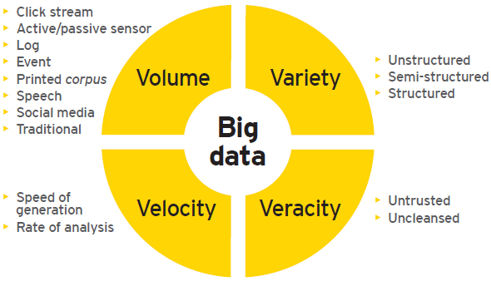

Figure 2.1 Characteristics of Big data [2]

**2.3.1 Volume**

Big data is quietly determine by its size which in case of four V’s of big data we call it as volume. Due to technological advancement the amount of data is being generated is growing rapidly. It could amount to hundreds of terabytes or even petabytes. Data is spread across different places, different formats in large volume ranging from gigabytes to petabytes. For instance 15 terabytes of Facebook post or 400 billion annual records of medical records could mean Big Data! Data is not only generated by human but also generating by machines. For example, a sensor in commercial plane to check engines condition capture 500GB of data each flight [10].

**2.3.2 Velocity**

Velocity means the rate at which data is getting generated. As data is getting generated at high speed, Big data requires fast processing of data. Time factor plays a vital role in many organizations. For example, processing 2 million records at share market, evaluating exam paper at public examinations could mean big data [10].

**2.3.3 Variety**

As its name is big data it may not belongs to a specific format. Variety refers to the different formats in which data is getting generated. Apart from structure data like spreadsheet and flat format, there is large number of unstructured data is getting generated like text, audio, video, log files, mails, sensor data, social media etc. New research shows that large amount of an organizations data is not numeric which is equally important for decision making. Business organizations are making use of both structure and unstructured data for data analysis and thereby making better business decisions [10].

**2.3.4 Veracity**

Veracity refers to the uncertainty of data availability. Sometimes available data can get messy and difficult to trust. As there are many forms of big data, quality and accuracy are hard to control like the twitter posts with emoticons and hashtags, typos and abbreviations. But now big data technology allows us to work with these types of data. Due to uncertainty, 1 of 3 business man do not trust the information they used in decision making [10].

**2.4 Scope of the problem**

Our scope of the project was to run analytics on a data depending on various use cases. That’s why we needed some tools of Hadoop like and we needed to learn them. Time scheduling was one of the difficult part of our project because we failed to do our project in time we would be great danger. We spend almost half of our time to analyze our problem that means to study about big data and its tools. It took almost four months to do our analysis. We spent one month to designing our system. Coding part took one month also and implementation part took almost one and a half month to complete. In total it took seven and a half months.

**2.5 Challenges**

As big data analytics is analytics of large size of data which is complex in type, we faced so many challenges to work with big data analytics. As we are not a business organizations first challenge was to data collections. After collections of data we faced so many challenges that we needed to overcome [11].

As big data analytics is a young technology and resource of big data in not enough in internet, we had to face so many trouble in completing our projects. To complete our project, we first needed to learn deep about big data and bid data analytics framework Hadoop and their ecosystems which was not easy for us.

Another challenge was the skills for the projects. At the begging of the project our skill was almost zero about big data analytics. As a new technology resource was not available in the internet and project also had to deliver his skills to the other members which was tough because of communication gap. However we had to overcame all these challenges and complete our projects.

**CHAPTER 3**

**REQUIREMENT SPECIFICATION**

**3.1 Hadoop**

Hadoop is an open source software framework used for storing and processing Big Data in a distributed manner on large clusters of commodity hardware. Hadoop is licensed under Apache v2 therefore Hadoop is known as apache Hadoop. Hadoop was developed based on a Google file system paper which was published on October 2003. This paper was generated from another research paper of Google named MapReduce: Simplified data processing on large clusters. Hadoop is written in java and one of the highest level Apache projects. Hadoop was developed by Doug Cutting Michael J. Cafarella.[6]

**3.2 Hadoop Architecture**

There were two major challenges in Big Data problem. One was data storage and another was data processing. As Hadoop came up as a big data solution, it solve the storage and processing issues. In Hadoop architecture, there are two major components. One is HDFS (Hadoop Distributed File System) and another is YARN (Yet Another Resource Negotiator). HDFS solved the storage issue and YARN solved the processing issues. Once data is brought into HDFS, mapreduce done with the processing part. YARN does all the resource management and scheduling these jobs. The Hadoop architecture is illustrated in figure 3.1



Figure 3.1: Hadoop architecture [1]

**3.3 HDFS (Hadoop Distributed File System)**

HDFS is one of the Hadoop’s major components and it refers to the storage part. Hadoop distributed file system is a java based distributed file system that allow us to store large data across multiple nodes in a Hadoop cluster which allow to multiple access and parallel processing. So if anyone install Hadoop he/she will get HDFS as storage system in the distributed environment.

HDFS allow its user horizontal scaling. Horizontal scaling means one can upgrade its storage system without parching additional components like RAM or CPU. They just needto add more nodes to the cluster to upgrade storage. HDFS also allow multiple replication across various nodes.

HDFS works in master/slave fashion.

**NameNode:** Name node is the master node in a cluster. There is only one master node per cluster. It contains the metadata information of all the slave nodes.

**DataNode:** Data node is the slave node which actually store the data. There are multiple data node a single cluster.

**3.4 MapReduce**

MapReduce is the processing part in Hadoop. It performs complex analysis on large set of data in a parallel fashion. MapReduce gives us flexibility writing code without bothering design issues of the system. MapReduce consists of two distinct tasks, one is Map and another is Reduce. As name suggest, reducer phase start after the finishing of mapper phase. First is the map job where blocks of data is read and process to produce key value pairs as an intermediate output. Then the output of the mapper job is the input to the reducer job. The reducer receive key value pairs input from multiple mapper output. Then reducer aggregates those intermediate data tuples into smaller set of tuples or key value pairs which is the final output. In a simple mar reduce program written in java has three different class. Mapper class, Reduce class and Driver class. Mapper phase implements into Mapper class and reducer phase implements into Reducer class and driver class define the type of input output formats, input output key class, output path and all other stuffs are implemented into driver class. Like HDFS, MapReduce works in master/slave fashion.

**Job Tracker:** Job tracker keeps the track ofthe assign jobs of the every data nodes in a cluster. Its responsibility is also to reassign failed job to the slave nodes and keep information about the jobs. There is only single job tracker in a cluster.

**Task Tracker:** Tasks tracker runs in the data nodes and its main responsibility is to complete the jobs it is assigned by the job tracker. There are multiple task tracker in a single cluster.

**3.5 PIG**

Apache Pig is a high level data flow system for creating programs that run on top of Hadoop. Apache Pig is designed to provide an abstraction over MapReduce and reducing the complexity of writing MapReduce program. Pig was developed by Yahoo in 2006 to allow developer using Hadoop focusing more on analyzing large data sets and spend less time on writing MapReduce programs. As name suggest Pig which eat almost everything, Apache Pig was designed to handle all kinds of data – hence the name!

Pig gives flexibility to programmers to write MapReduce job who don’t know programming language like java or python. Pig helps developers to write MapReduce job as approximately 10 lines of Pig script is equal to 200 lines of MapReduce program! Hence it reduce the development times 20 times shorter. That is why every developer chose Pig as a data processing language over MapReduce java program although they know java or python.

**3.5.1 Pig Architecture**

Apache Pig is made of two major components, one is the language itself which is known as **PigLatin**, another one is the runtime environment where PigLatin programs are executed which is known as **PigLatin compiler**. Just like java virtual machine and java application. The architecture of apache Pig is illustrate in fig 3.2.

**3.5.1.1 PigLatin Script**

PigLatin script is a programming language of apache Pig. There are three way to run piglatin script. First one is grunt shell, where we write piglatin script in the grunt shell and execute it. Secont one is to write the script into a script file and run it in the command line. Another one is Pig user defined function which extends the pigs built in functionality.

**3.5.1.2 PigLatin Compiler**

Pig Latin compiler converts the pig latin codes into executable code. The executable code is in form of MapReduce jobs. The sequence of MapReduce programs enable pig programs to do data processing and analyzing in parallel.

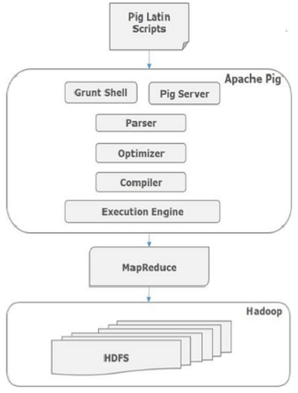

Figure 3.2: Architecture of Apache Pig [3]

The different between MapReduce and PigLatin is that we can achieve everything with MapReduce and we can achieve almost everything with PigLatin. That means is some case PigLatin may not work properly like so many loops need to use. Otherwise Pig Latin is not very mature and it was developed to handle ad-hoc level data processing.

**CHAPTER 4**

**DESIGN SPECIFICATION**

**4.1 Introduction**

We need to install Hadoop to work with Big Data. As most of us are not comfortable with UNIX operating system we will take help of virtual machine. A Virtual machine is a software computer like physical a computer that runs an operating system and applications. Virtual machine comes up with some build in big data tools like Hadoop, Hbase, Spark, Impala etc. There are so many virtual machine in the internet like cloudera vm, sandbox vm, edureka vm. Cloudera vm is most popular of them. We use edureka virtual machine for our project. Edureka virtual machine comes with CentOS 6.5 operating system amd all other Big Data tools.

**4.2 Virtual Machine Installation**

Installation of Edureka Virtual machine is very useful for working with Hadoop as it comes with some pre-built Big Data tools.

Minimum hardware requirements for installing Virtual machine on Windows are

* Minimum 4 GB RAM or above
* Dual core processor or above
* 20 GB free Hard Disk space to run VM smoothly

These step by step need to be followed to install virtual machine:

Step-1: Download open source virtual box from below link [7]

https://www.virtualbox.org/wiki/Downloads

Step-2: Download Edureka virtual machine.As it is not an open source virtual machine, normal user can’t download it, only some user who paid for it can download it. Other can download Cloudera virtual machine from the below link [8]

https://www.cloudera.com/downloads/quickstart_vms/5-8.html

Step-3: After downloading both first we need to install virtual box. After installing below screen illustrate in figure 4.1 will appear. Then we need to import **.oav** file into the virtual box.

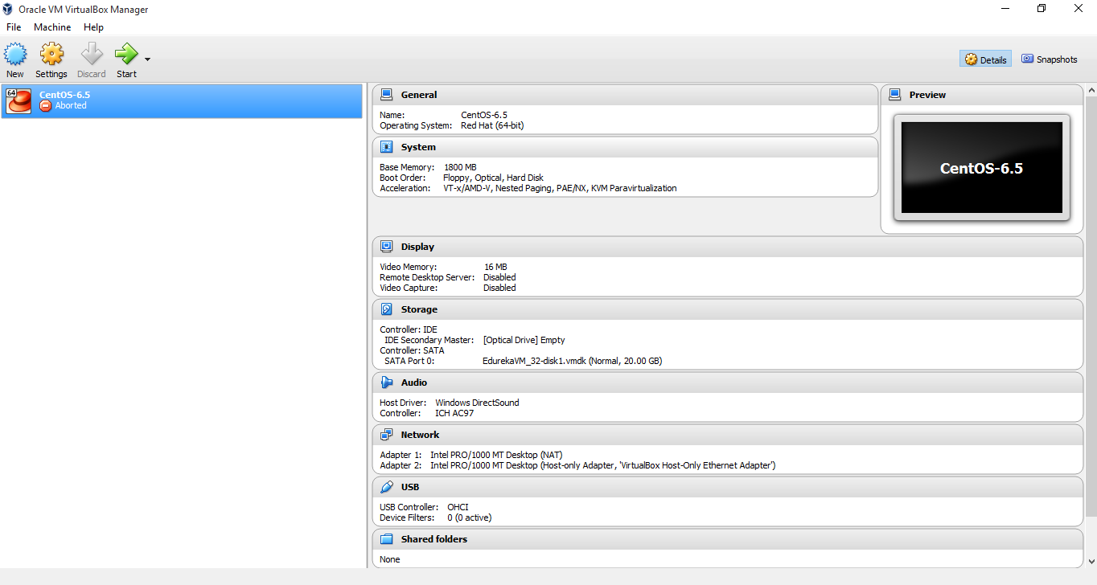

Figure 4.1: Virtual machine installation

**4.3 Virtual machine configuration**

After importing virtual machine we need to adjust hardware and network configuration.

First go to setting and then go to system setting. Path is **setting->system**

Then we need to specify **Base RAM.** While selecting base ram always select **30-35%** of total ram to run vm smoothly.

Then we need to specify network setting. Go to **setting->network** and select adapter 1 as **NAT** and Adapter 2 as **Host-only-Adapter.**

Then click start in start button. It will take some times and virtual machine home screen will appear.

Select Edureka and type password as **“edureka”.** In case of Cloudera type “cloudera” as password. Then home screen will apeear like figure 4.2

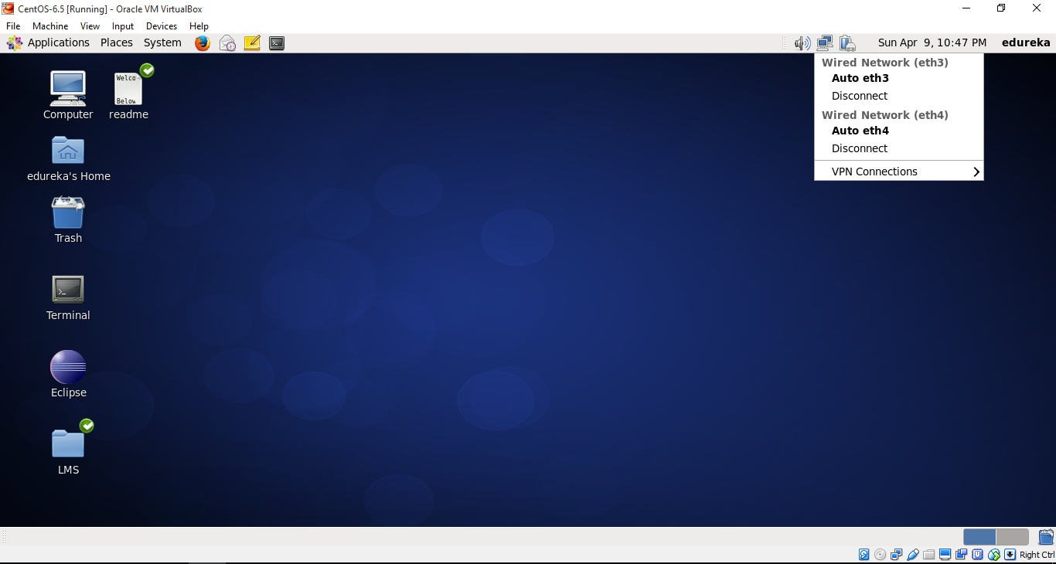

Figure 4.2: Home screen of Edureka Virtual Machine

**4.4 Loading Data into HDFS**

Before working with Hadoop we need to check if all the daemons are running properly or not. The command is **sudo jps** and give password as “edureka”. The output will be like figure 4.4. As we are working on pseudo distributed mode that means name node and data node are in the same machine the output will be like exactly the figure 4.4.

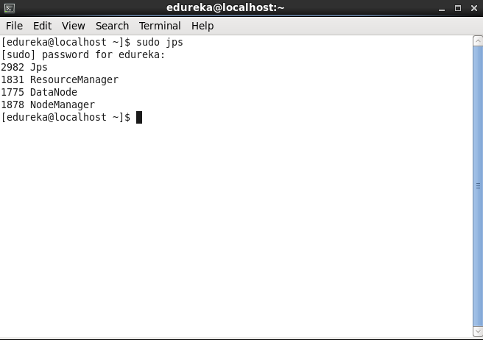

Figure 4.3: Checking all the daemons of Hadoop

First we need transfer file from local machine to virtual machine using **FileZilla** a FTP utility which is used to transfer file over the internet.

Following Hadoop commands is that are used to perform different operation on HDFS.

**$hadoop version:** to check Hadoop version

**$hadoop dfs –mkdir:** to create directory into HDFS

**$hadoop dfs –copyFromLocal <file_path> hdfs:/** : to upload file into HDFS

**$hadoop dfs –rm –r:** to remove a file from HDFS

**$hadoop dfs –ls**: check the file list in the HDFS

**Step-1:** Move file name movite.txt into HDFS from local system using below command

**$hadoop dfs –copyFromLocal ‘/home/edureka/Desktop/movie.txt’ hdfs:/** asfigure 4.5

**Step-2 :** check whether file has uploaded into HDFS or not using below command

**$hadoop dfs –ls /** as figure 4.5

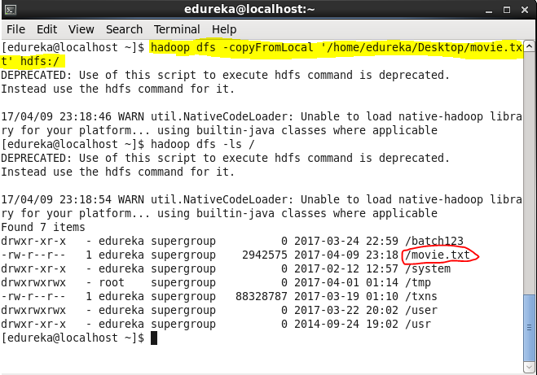

Figure 4.4: Copy data into HDFS from local system

**Step-3 :** After copying file from local file system to HDFS a sanity check can be perform to check for the data present in the HDFS file browser or not. Step are below

First open Mozilla Firefox

Then in the search button type **localhist:50075**and press enter which will take us to the NameNode WebUI.

Then go to browse the file system and check if it is available or not. Output will be exactly the figure 4.6

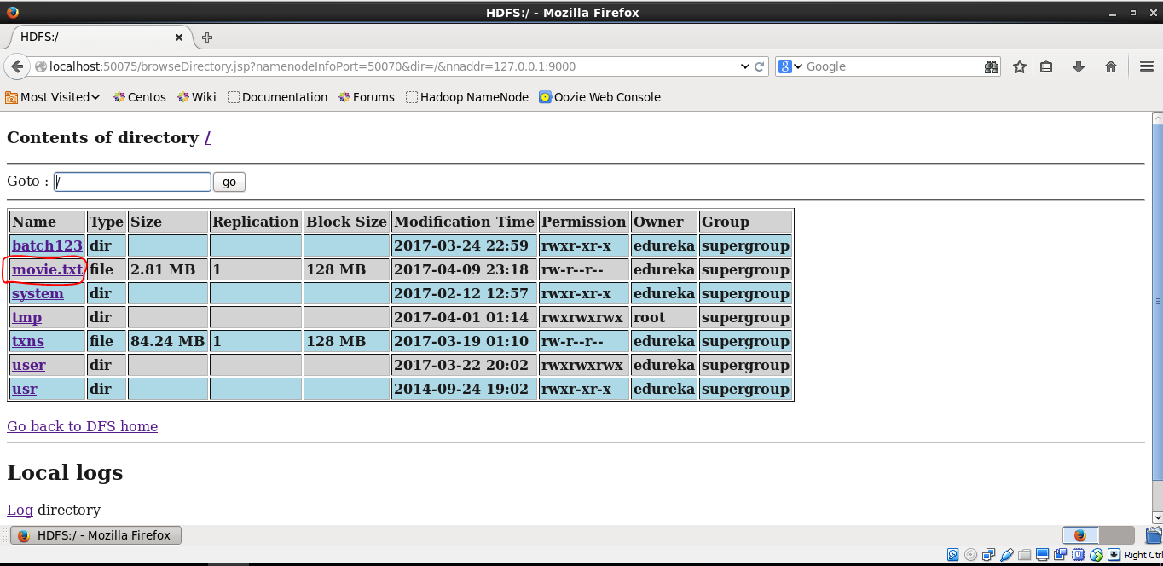

Figure 4.5: Data sanity check in HDFS web log

**CHAPTER 5**

**IMPLEMENTATION AND TESTING**

In this chapter we will describe about movie data set we are using for our analysis and each steps of analysis.

**5.1 Movie data set**

Movie data set consists of almost fifty thousand records of movie collection from 1913 to 2014. We collect our test data set from the following link.

https://edureka.wistia.com/medias/7qd5lgmko4

Although data is in comma separated value (CSV) which is a structured data we will analyze our data at Big Data analytics fashion. A detailed description of the movie data set is described in table 5.1

**Table 5.1: Description of the movie data set**

|  |  |
| --- | --- |
| **Field** | **Description of the field** |
| Column 1 | Id of the movie |
| Column 2 | Name of the movie |
| Column 3 | Year of released of the movie |
| Column 4 | Rating of the movie |
| Column 5 | Duration in seconds of the movie |

From description we can see that data set is structured although Hadoop was found for unstructured data analytics. We will analyze our data set in a Big data analytics fashion as we are not he production environment and collecting of unstructured data is so tough. We chose Pig as a analytical tools as we are not from java background and Pig helped us reducing development time. A snippet of the CSV (comma separated value) format movie data set is shown in the Figure 5.1

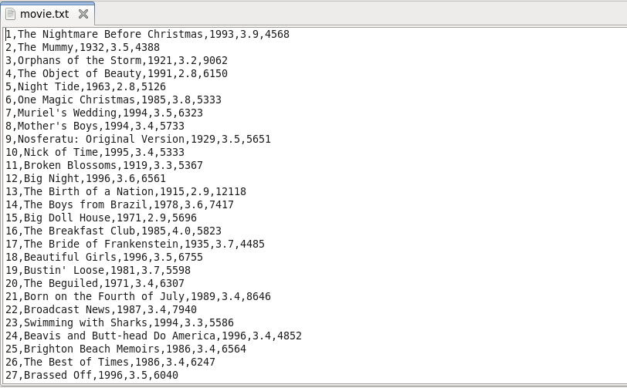

Figure 5.1 Sample movie data set in CSV format

**5.2 Movie Data Analytics**

Different use cases have been considered to perform data analytics on movie data set. Detailed on the different use cases and implementation details have been provided below. The output of the data analytics also have been provided.

**5.2.1 Use Case 1: Number of movies released between 1950 and 1960**

First we need to load our data into HDFS which we have done in previous chapter. Now we need to enter into Pig grunt shell. There are two mode of Pig grunt shell, one is local mode and another is mapreduce mode. To enter into the local mode we will type **pig –x local** and to enter into mapreduce mode we will type **pig –x mapreduce.** As we areworking on mapreduce mode we will type pig –x mapredduce and then figure illustrate in figure 5.2 will appear.

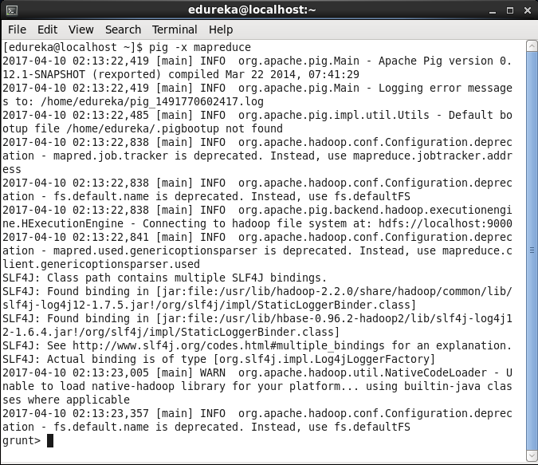

Figure 5.2: Starting Pig grunt shell in MapReduce mode

Loading data using pig is shown in figure 5.3

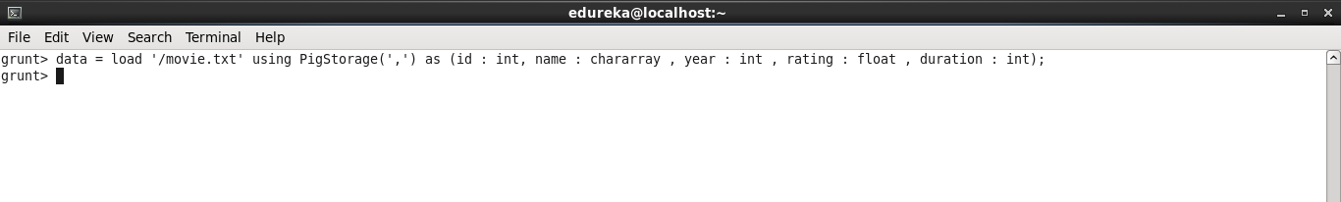

Figure 5.3 Loading data using Pig

A Pig script was written in grunt shell to accomplish this which is visible in figure 5.4

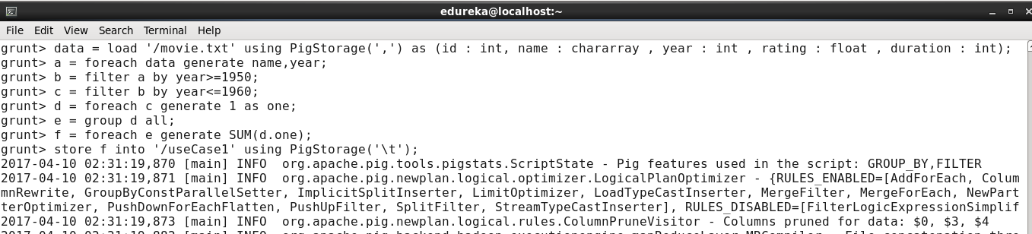

Figure 5.4 Execution of the script of the use case 1

Figure 5.5 show the successfully execution of the script

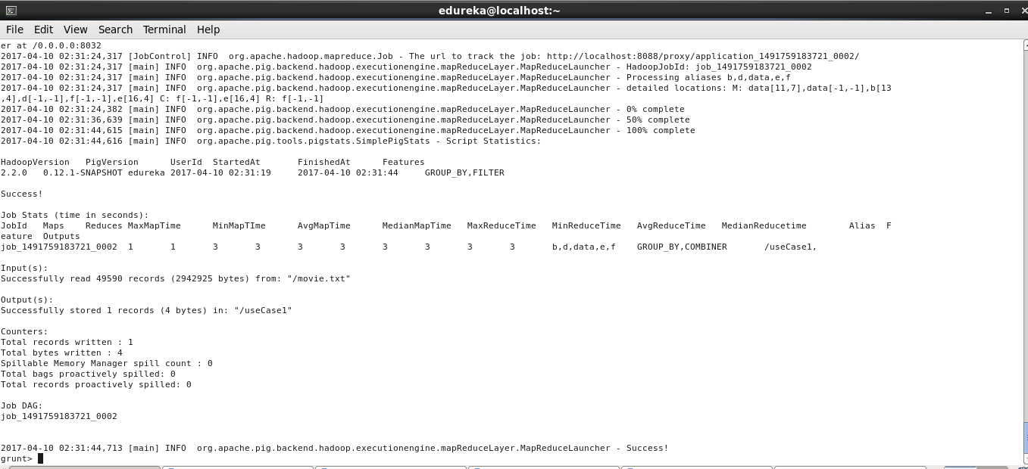

Figure 5.5 Successful execution of the script of use case 1

Below screenshot show the result of script stored into HDFS.

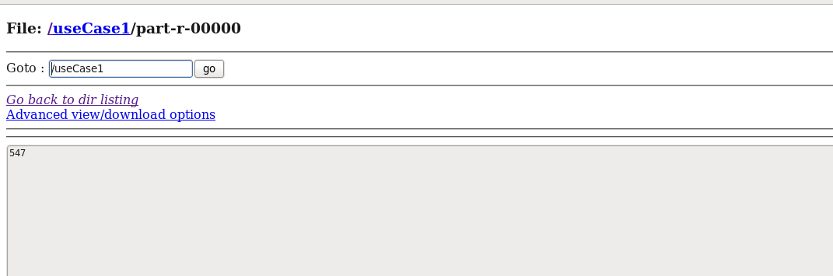

Figure 5.6 Output of the use case 1 in HDFS

**5.2.2 Use case 2: Find movies having rating more than 4**

As we already load data using data alias we don’t need to load data again into pig. We just need to write another script to find the movies having ration more than 4. Figure 5.7 illustrate the script.

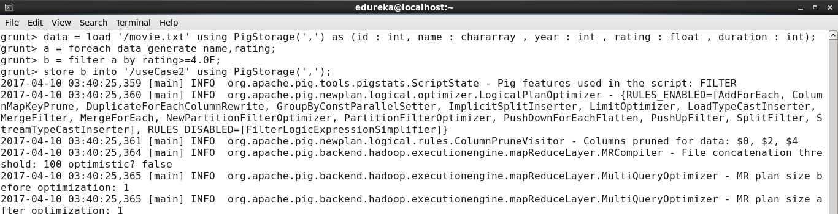

Figure 5.7: Use case 2 pig script

After successful execution of the below figure is show in the command shell.

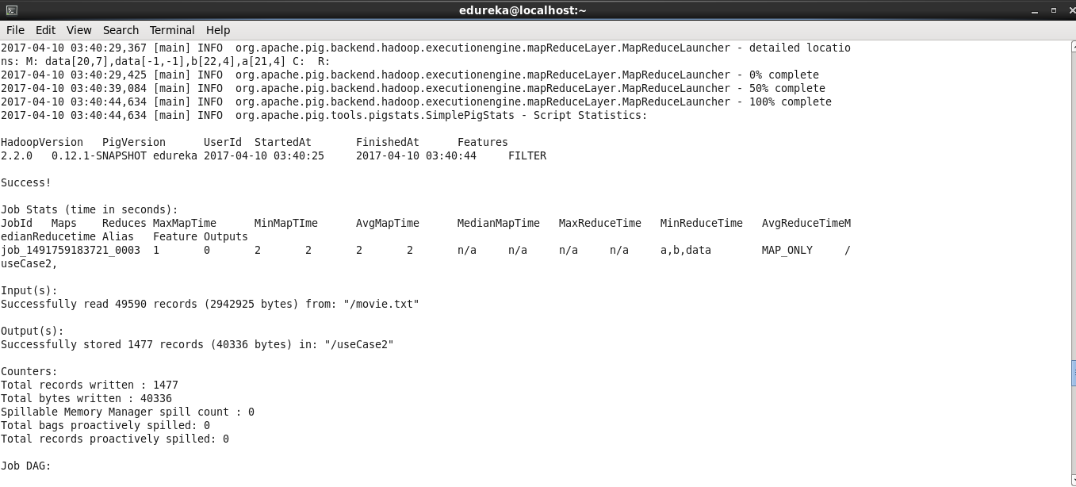

Figure 5.8: Successful execution of Pig script of use case 2

Then we need to check output into the HDFS. Below figure shows the output of the use case 2.

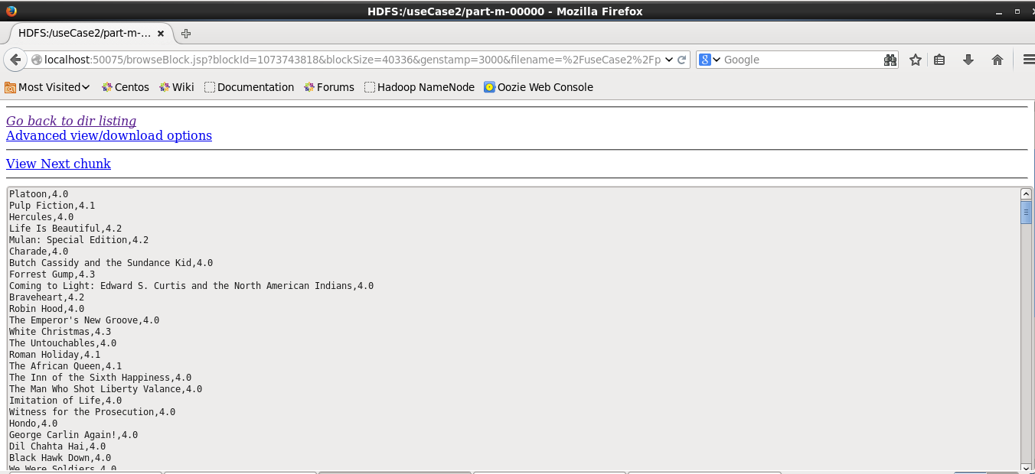

Figure 5.9: Output of the use case 2 in HDFS

**5.2.3 Use case 3: Finding movies having rating between 3 and 4**

To finding the movies which rating is between 3 and 4 we need to write a script that is illustrate in figure 5.10

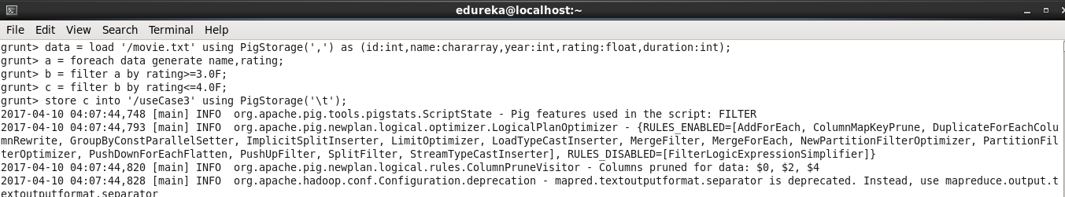

Figure 5.10: Pig script of use case

Below figure show the successful execution of pig script of use case 3.

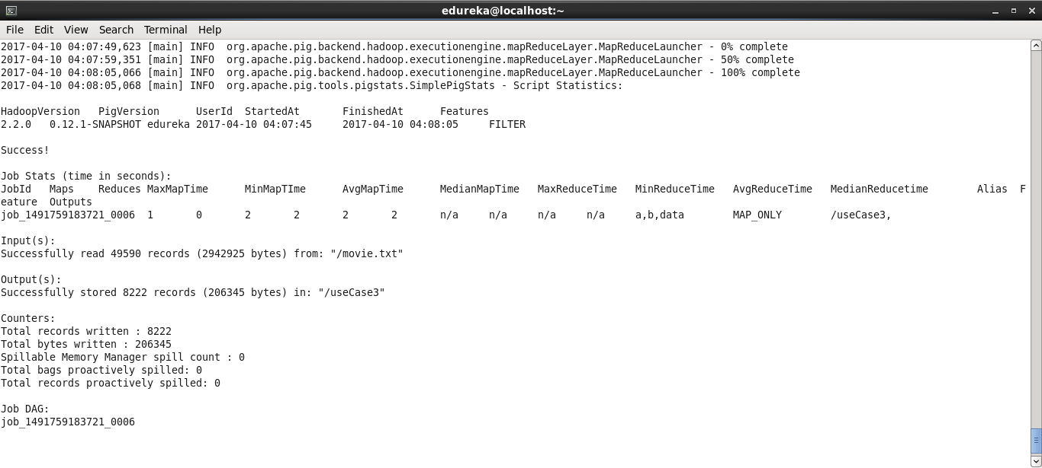

Figure 5.11 Successful execution of Pig script of use case 3

Below figure show the output of the use case 3

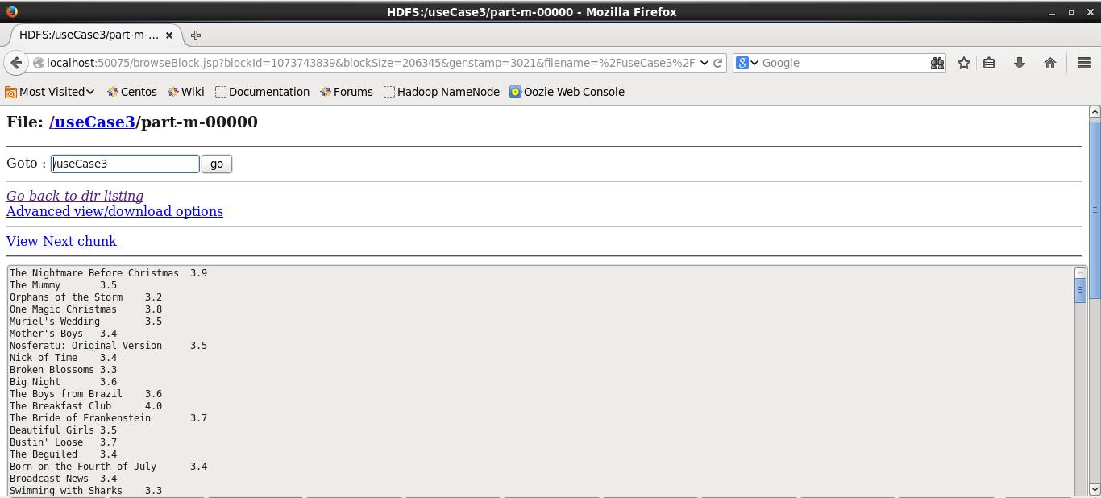

Figure 5.12 Output of the pig script of the use case 3

**5.2.3 Use case 4: Finding List of Year and Number of Movies Each Year**

To find list of year from the data set and the number of movies each year we need to write a pig script. As data set is already loaded into pig we don’t need to load data again into the pig. Below figure show the script of the use case 4.

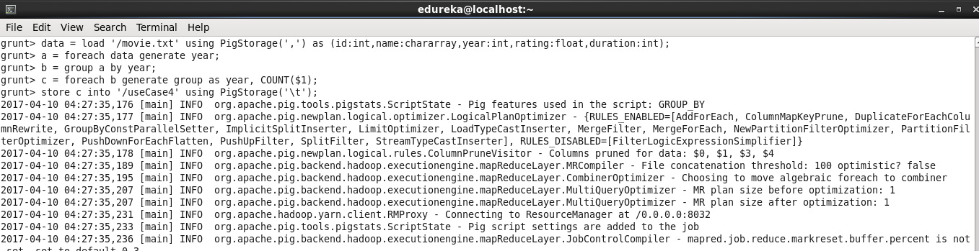

Figure 5.13: Pig script of use case 4

After running pig script a successful execution message will appear in the command shell.

Figure 5.14 illustrate the successful execution message.

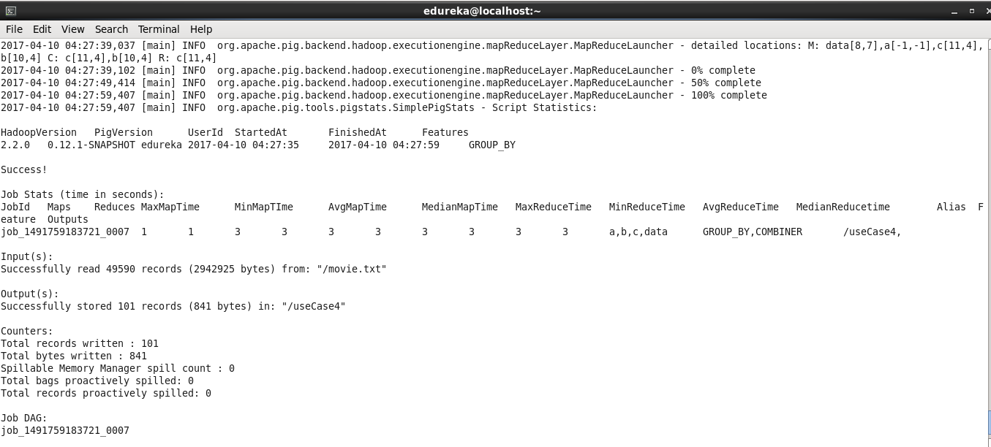

Figure 5.14: Successful execution of Pig script of use case 4

Then we need check the output in the HDFS. Below figure show the output of the pig script of use case 4 which contains all the list of year and number of movies each. Below figure show the output of the Pig script of the use case 4.

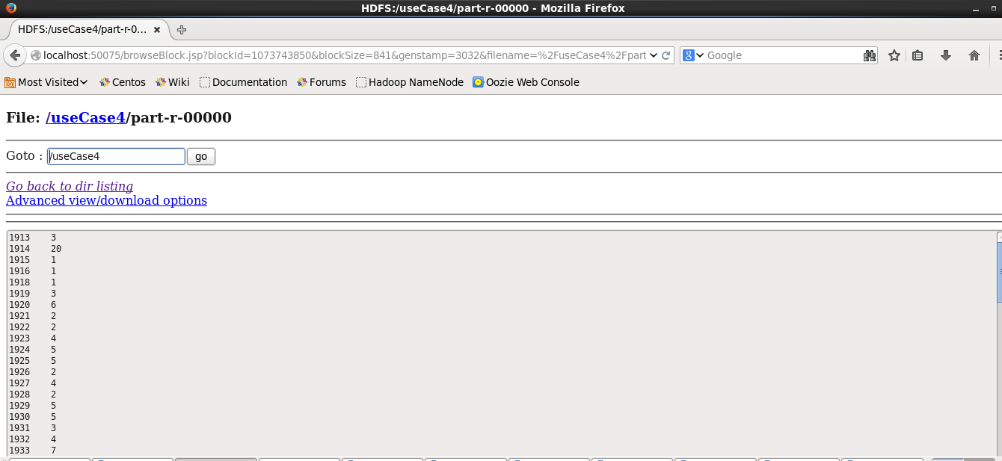

Figure 5.15: Output of the pig script of the use case 4

In this chapter we show the data set description and analyze our test data set using Pig. We chose Pig over MapReduce because if we would chose MapReduce it would be so tough for us to get the desire result of each use cases. By using Pig it saves our development time. We also show four use case and also show each use case implementation with their screenshot.

**CHAPTER 6**

**CONCLCUSION AND FUTURE SCOPE**

**6.1 Discussion and Conclusion**

By the grace of almighty Allah we just completed our project and documentation. After the long session of studying about big data, Hadoop, Hadoop components and being comfortable of all the ecosystem of Hadoop, designing and last implementation we point that instead of completion. Completing a project on big data analytics was a big challenge for us and we complete our project successfully.

**6.2 Scope for Future Development**

In our project we use pseudo distributed mode in cluster set up. We will work in future will multi-mode cluster set up. We use a CSV file as our test data set, in future we will work with critical data set format like JSON format.

**APPENDICES**

**Appendix A: Project Reflection**

The purpose of this appendix is to provide an introduction to **Project Reflection.** The group research was project was a challenging and enjoyable experience typical of the course as a whole. We have had little exposure to group work at university so it was a nice change to be part of an effective and dynamic team. I think we complemented one another quite well both in bringing together interdisciplinary perspectives and in balancing the work at hand.

The experience taught us that planning and crafting responses take a longer time in team than on your own. The extensive effort required was ultimately a good thing. When working alone, you can end up with a result that is identical to your initial plans. In our group, we were constantly developing and refining one another’s ideas. It was fascinating just how productive our group meetings were. The time seemed to fly and yet we always got a lot done and managed to help another along the way towards the endpoint of having a substantive policy.

**Appendix B: Related Diagram**

The purpose of this appendix is to provide an introduction to **Related Diagram(**RD**)** and pointers to some of the foundational references.

**REFERENCES**

**[**1**]** Deepthi Yaramala, “HEALTH CARE DATA ANALYTICS USING HADOOP”, http://www-rohan.sdsu.edu/~eckberg/HadoopHealth/Health.html, [Last Accessed on 3rd April 2017 at 9:05am].

[2]EY’s Big Data: changing the way business compete and operate, http://www.ey.com/gl/en/services/advisory/ey-big-data-big-opportunities-big-challenges, [Last Accessed on 23th January 2017 at 7:30 pm].

[3] Apache Pig-Architecture, https://www.tutorialspoint.com/apache_pig/apache_pig_architecture.htm**,** [Last Accessed on 10th February 2017 at 10:37 am].

[4] Neelam Singh, “Big Data – insights, motivation and challenges”, http://www.ijser.org/researchpaper%5CBig-Data-insights-motivation-and-challenges.pdf, [Last Accessed on 20th December 2016 at 8:47 pm].

[5] Introduction, https://en.wikipedia.org/wiki/Big_data, [Last Accessed on 17th February 2017 at 6:45 pm].

[6] Apache Hadoop, https://en.wikipedia.org/wiki/Apache_Hadoop#History, [Last Accessed on 7th March 2017 at 9:30am].

[7] Virtualbox download, https://www.virtualbox.org/wiki/Downloads, [Last Accessed on 30th January 2017 at 4:47 pm].

[8] Virtual Machine installation, https://www.cloudera.com/downloads/quickstart_vms/5-8.html, [Last Accessed on 26th January 2017 at 10:30pm].

[9] Alice Macfarlan, “Big Data and Evaluation – Use and Implication” http://www.betterevaluation.org/en/blog/big_data_in_evaluation, [Last Accessed on 29th March 2017 at 6:12 pm].

[10] Characteristics of Big Data, https://www.edureka.co/blog/the-hype-behind-big-data/, [Last Accessed on 07th February 2017at 10:30 pm].

[11] Neelam Singh, “Big Data – insights, motivation and challenges”, http://www.ijser.org/researchpaper%5CBig-Data-insights-motivation-and-challenges.pdf, [Last Accessed on 20th December 2016 at 01:23 pm].

**PLAGRIARISM REPORT**

